**INSTRUCTIONS TO DOWNLOAD VUMIE2012 FOR BIOS242**

Hello class,

This session, we will doing all our labs online. In order to do these labs, you need to download software called Virtual Unknown (VUMIE 2012). Complete details to download the software are given below.

**Getting Your License Key for VUMIE 2012**

Click on the Course Resources in your course shell under Course Home. Scroll down to see the Student Software Store (SSS) link. Click on the Student Software Store tab indicated by the arrow.

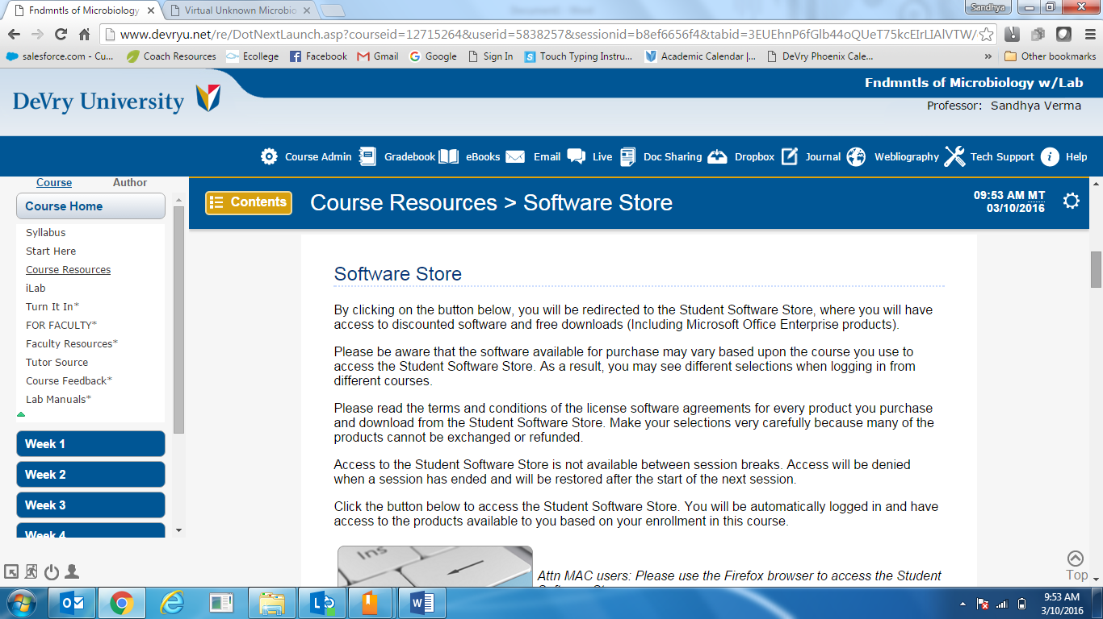

Next click on the “Go to the Student Software Store” tab indicated by the arrow.

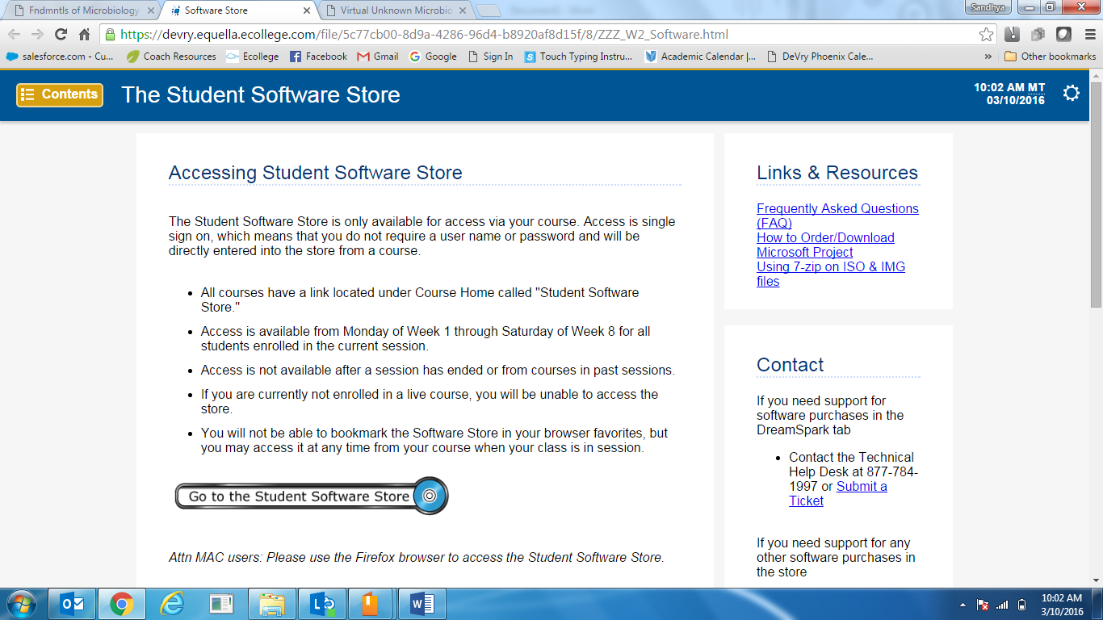

Next click on Course Related Software to see the “Virtual Unknown Microbiology” link. Click on this link

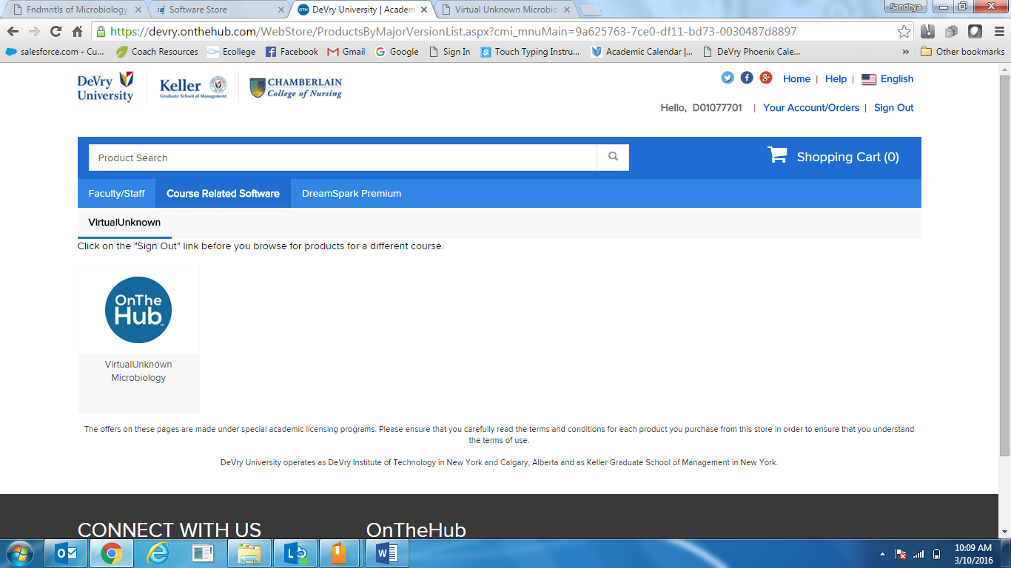

Add the software to your cart. (If you have previously used Virtual Unknown, you will be unable to add it successfully. Please contact the Home Office Helpdesk and open a ticket to address this issue.)

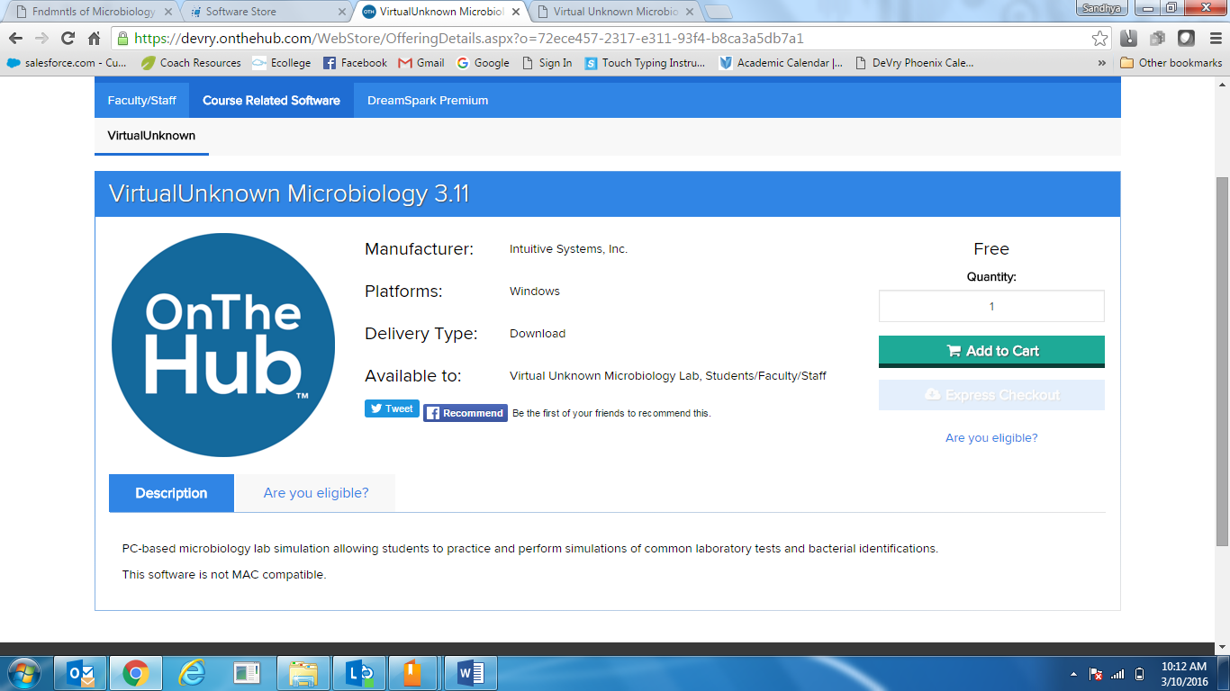

Once you purchase the software, it will give you access to a redemption code that you will need to log into the lab the first time.

**Accessing the VUMIE 2012 Software**

Please go through the Getting Started Tutorial by clicking the ilab section in Course Home. This tutorial has information on how to download Citrix, which is the platform needed to run the labs. In order to download Citrix, you will need administrator rights on your computer. Once you download Citrix and log into it using your D number and system password, you be able to see the VUMIE2012 icon (which looks like a red-green circle) under Applications.

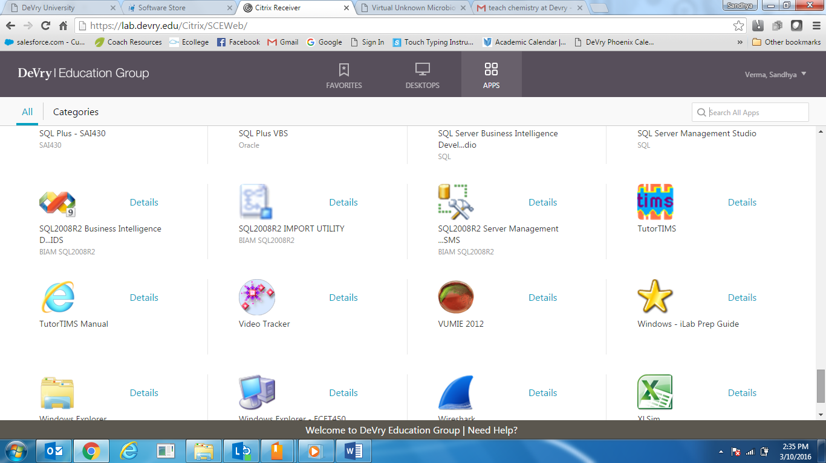

When you log in to the iLabs the first time, please put “DeVry” as your institute even if you are Chamberlain students.

The instructions to perform experiments every week are in the iLab section for that week.

For any technical issues, please contact the Help Desk at 877-784-1997.