Chamberlain Care and Master Instruction Pedagogy - Transcript

1 - Title Slide
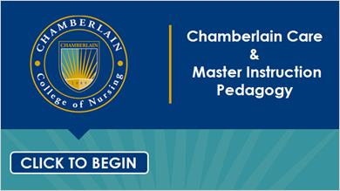

2 - Chamberlain Care

We are not just another College of Nursing-we are distinctly Chamberlain College of Nursing. Our distinction is rooted in our culture of care-Chamberlain Care®-that permeates every aspect of the College, and is embedded in the mindful actions of each and every one of us. Chamberlain Care is our way of being: caring for ourselves informs and sustains caring relationships with our colleagues, students, patients, and the community we touch.

3 - Chamberlain Care
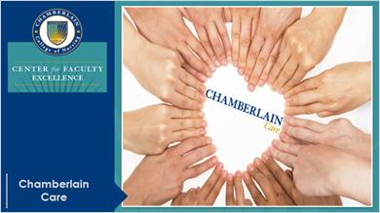
Chamberlain Care unites us together, and creates oneness out of our many.

4 - Chamberlain Care
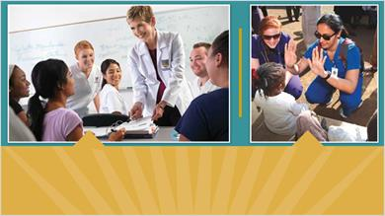
Through Chamberlain Care and the ideals it embodies, we model and teach our students the values that are exemplified by extraordinary nurses - caring, professionalism, excellence, integrity, and service. We believe if we take extraordinary care of our students, we will graduate extraordinary nurses who can have a significant and positive impact on healthcare around the world.

5 - Chamberlain Care
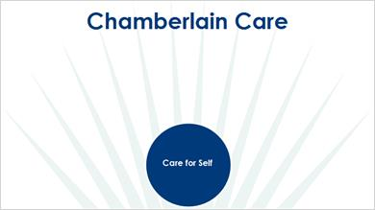
Chamberlain Care begins with care for self. To care for others, we must first take care of ourselves so that we have the capacity to do our best each day.

6 - Chamberlain Care
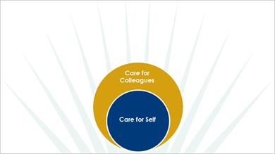
Care for colleagues. Demonstrating care and support of colleagues creates a workplace environment of respect, collaboration, collegiality, creativity, productivity, and teamwork.

7 - Chamberlain Care
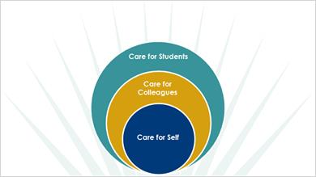
Care for students. Chamberlain Care reflects our fundamental belief in our responsibility and ability to achieve superior student outcomes. At Chamberlain, our focus is keeping students in the program, not weeding them out, which is why faculty passionately work with students to transform challenge into success. Our care for students is actualized through initiatives that lead to teaching excellence and provide extraordinary care and strong support for each student’s learning experience.

8 - Chamberlain Care
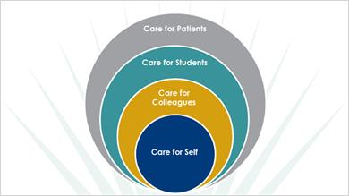
Our core ideals are expressed through Chamberlain Care practices that ultimately lead to extraordinary care of patients, families, communities, and nations. We take extraordinary care of our students and teach them how to take extraordinary care of the people and families entrusted to their care.

9 - Chamberlain Care
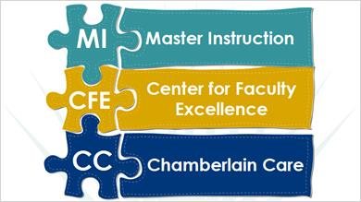
Chamberlain Care also provides the foundation for our dedicated faculty development program offered through the Center for Faculty Excellence. This program enhances knowledge, skills, and attitudes for beginning and experienced nurse educators within a creative and supportive environment. Through our innovative pedagogy, called Master Instruction, faculty are nurtured in the art and science of scholarly teaching.

10 - Master Instruction
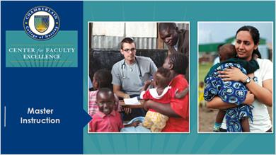
Master Instruction is Chamberlain Care in Action. This transformative pedagogy champions care for faculty and students, and supports formation of extraordinary nurses who transform healthcare around the globe.

11 - Master Instruction
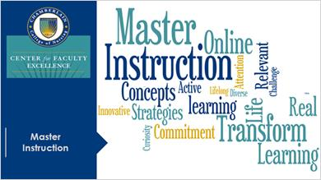
Master Instruction was conceived in response to the urgent call to transform educational practice, and is central to Chamberlain's commitment to excellence in teaching and learning nursing. This pedagogy challenges perceptions about the teaching and learning process and creates a positive, participatory learning environment through deliberate use of evidence-based strategies to foster deep student learning.

12 - Master Instruction

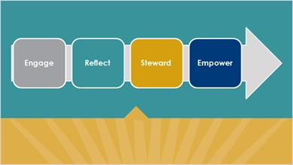
Key themes identified to support faculty formation led to sequencing of our faculty development courses by content; that is, each phase of professional development is guided by courses built on constructs that reflect learner development in Master Instruction.

13 - Master Instruction
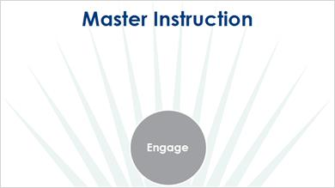
Following introduction to Master Instruction, initial faculty development courses engage faculty in learning about learning. This transition contextualizes the faculty role from one of content delivery to student engagement across learning environments.

14 - Master Instruction
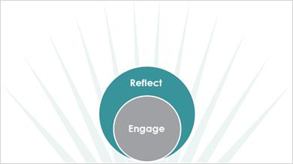
Subsequent courses encourage faculty to reflect on evidentiary learning methodologies as the vehicle for student engagement. An emphasis on scholarly teaching includes the deliberate use of evidence-based teaching and learning strategies to successfully facilitate achievement of course and program outcomes.

15 - Master Instruction
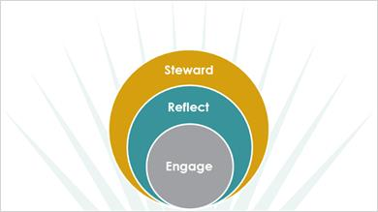
At the next level, courses guide faculty to steward Master Instruction as they perform in the role of Master Instructor. This transformation is evidenced by faculty interactions with students and colleagues. As the word Steward implies, faculty watch over, encourage and support other faculty, and create a lasting impact that imprints on the lives of others.

16 - Master Instruction
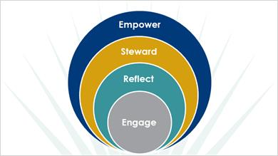
Later courses empower faculty to create an extended influence at Chamberlain and beyond, to the profession of nursing and the development of nursing education knowledge. In this phase, faculty serve as mentors, scholars, and leaders, reinvesting passion, talent, and commitment to faculty colleagues and the community at large.

17 - Master Instruction
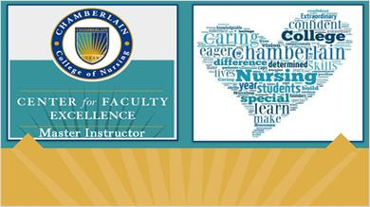
Given that the strength of a teaching-focused college is in the faculty who provide instruction, the Center for Faculty Excellence created meaningful recognition for faculty achieving excellence in teaching through the distinction of Master Instructor. At the heart of this distinction is Chamberlain Care as the essence of excellence.

18 - Master Instructor I Distinction
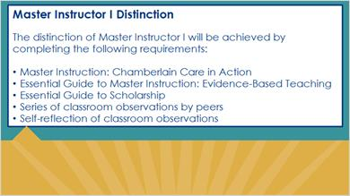
Distinction requirements are academic and professional, and are leveled. You don’t have to journey alone to become a Master Instructor. Faculty Development Specialists, Master Instruction Champions, and mentors are available to guide you on your way to becoming a Master Instructor.

19 - Master Instruction

Integral to the transformative process of Master Instruction is gaining new insight into the deliberate use of evidence-based strategies to deepen student learning and creating a positive, participatory learning environment that aligns with the realities of today’s nursing practice.

20 - Impact of Master Instruction
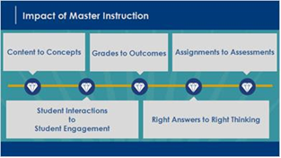
Through Master Instruction, emphasis shifts from content to concepts, from student interactions to student engagement, from grades to outcomes, from right answers to right thinking, and from assignments to assessments.

21 - Chamberlain Care and Master Instruction Pedagogy
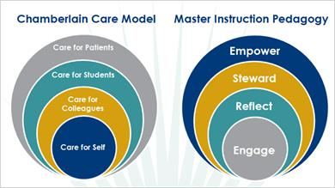
In juxtaposition, these Venn diagrams show Chamberlain’s Care Model aligned with Master Instruction Pedagogy. Chamberlain care as a philosophy begins with self, and expands in import as caring extends beyond self to include colleagues, students, and the community at large. Similarly, Master Instruction as a pedagogy begins with self, as faculty engage in self-analysis of their teaching practices. With increasing insight and self-awareness, faculty can then begin to reflect on why helping students learn to learn is essential to scholarly teaching.

22 - Chamberlain Care
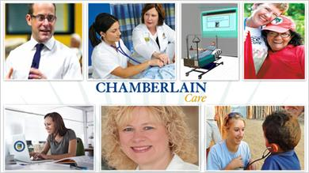
As stewards of new ways of knowing about the ‘why’ of their teaching, faculty are empowered not only to grow in the ‘what’ and ‘how’ of their own teaching practice, but also to shepherd other faculty in new ways of knowing through leadership, mentorship and scholarship that has outreach to the community at large. At Chamberlain, we believe that how we learn is as important as what we learn, that we care for our students in the same way nurses care for patients, and that what we do makes the world a better place through impacting the health of the global communities we serve.

23 - Chamberlain Care
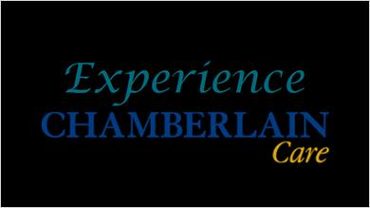
Please watch this video to experience Chamberlain Care.

