Co-Construction of Teaching Skills

Peer observation handbook

Academy for teaching and learning



September 2020

# 

Contents

1 Foreword 3

2 Introduction 4

3 Overview of the peer observation process 5

4 Details of the peer observation process 6

4.1 Confirm peer 6

4.2 Individual and Common Teaching Goals 7

4.3 Schedule Observation 8

4.4 Share Documents 9

4.5 Briefing session 10

4.6 Observe & Take Notes 11

4.7 Debrief Session 12

5 References 13

6 Appendix 14

6.1 Framework for Setting SMART Goals 14

6.2 Teaching Competencies to Guide Observation 16

6.3 Data Sources 23

6.4 Brookfield’s four lenses 23

6.5 Individual Teaching Goals Template 24

6.6 Lesson Plans (Classroom, Clinical Teaching and Workshop Examples) 26

6.7 BOPPPS Framework – Lesson Plan for Workshops 29

6.8 Teaching Observation Form 31

6.9 Joint Statement – Peer Observer and Peer Teacher 32

6.10 Annotated Sample of Teaching Goals Document 33

6.11 Annotated Sample of Lesson Plan Document 34

6.12 Annotated Sample of Teaching Observation Document 35

6.13 Annotated Sample of Joint Statement Document 36

Word Version of Document

# Foreword

This handbook is designed for educators at Ross University School of Medicine. It presents detailed steps for conducting peer observation of teaching. It also provides guidelines for aligning the process with the educator’s own professional development goals with those of the organization.

The process presented in this handbook is designed to develop teaching skills in an environment that has been co-constructed by the peers by applying principles of social construction.

For the purpose of the handbook, we have the following definitions.

|  |
| --- |
| Lecturer Peer teacher: the individual being observed |
| Eye Peer observer: the individual conducting the teaching observation |

# Introduction

Based on a review of teacher domains of practice, the ATL has determined the following five domains of teaching as outlined in Table 1. [Please see: The Domains of Teaching.](https://lms.courselearn.net/lms/CourseExport/manual/interactives/ROSS/ATL/certs/cert_305/cert_305_202020_domains/story.html)

*Figure 1: Domains of Teaching.*

The domains of teaching provide a framework to evaluate your own teaching.

# Overview of the peer observation process

In the area of teaching effectiveness, there is agreement that teacher performance cannot be limited to any one universal model, therefore, teaching observation must reflect and record the interactions between teachers and students that are specific to the context of the learning environment and the teacher’s teaching goals. Therefore, for the observation to be fair and equitable to both the teacher and evaluator it is recommended that the competencies to be observed are identified *a priori*.

For each step, this document provides details on the following:

|  |  |
| --- | --- |
| Closed book  Overview | An overview of the step and how it fits into the entire process. |
| Checklist RTL  Steps | Steps involved in the process from the perspectives of both the peer observer and the peer teacher. |
| Resources | Resources required to complete the step which will be linked to the appendix. |

# Details of the peer observation process

## Confirm peer

|  |  |
| --- | --- |
| Closed book  Overview | The objective of this activity is to enable all participants to pair with a peer with whom they will collaborate. |
| Checklist RTL  Steps | Identify a peer based on your professional development goals. Your peer may have similar or different teaching experience as you (e.g. department, discipline, teaching setting etc.) |
| Resources | What are the similarities and differences between your peer and you in terms of disciplines/specialties, predominant teaching environment (E.g. large group setting, small group or bedside) and the teaching domain of interest (refer to the five domains of teaching)? |

## Individual and Common Teaching Goals

|  |  |
| --- | --- |
| Closed book  Overview | Faculty should set individual goals based on a critical reflection of their current teaching practices. This reflection should be framed within the ATL Domains of Teaching.  Participants will also collaborate with their peer to set common goals. These common goals will inform the peer observation process. |
| Checklist RTL  Steps | * Set at least three individual teaching goals that you would like to pursue during this course. Use the following questions to guide your goals setting:   + - What is your rationale for selecting these goals?     - How do these goals support your MAP 365 goals?     - How will they help you enhance your teaching?     - What action steps will you take to achieve your goals?     - What resources will you need?     - How will you measure the outcome or success? * Review your individual goals with your peer. Then create a set of common teaching goals that will inform the peer observation process. |
| Resources | * Use Brookfield’s lenses to guide reflection * Use Teaching Competencies Performance Standards to guide goal setting * Use Framework for setting SMART goals * Use Goal setting template to document goals |

## Schedule Observation

|  |  |
| --- | --- |
| Closed book  Overview | Once the goals are set, participants will identify teaching activities to observe and be observed.  This is followed by sharing of teaching schedule and setting observation dates and times for all the sessions if possible |
| Checklist RTL  Steps | 1. From your teaching schedule, outline the courses you will teach during the span of the certificate. 2. Identify potential observation times/dates near the middle of a course or training session that would best reflect typical teaching encounters with your students. |
| Resources | Share each other’s schedule. |

## Share Documents

|  |  |  |
| --- | --- | --- |
|  | Lecturer Peer teacher | Eye Peer observer |
| Closed book  Overview | In this step, the peer teacher shares all documents pertaining to the teaching session with the peer observer. | In this step, the peer observer receives all documents pertaining to the teaching session from the peer teacher. |
| Checklist RTL  Steps | * Compile all relevant and applicable documents to be shared with the peer observer. * The observation document includes the peer teacher’s individual teaching goals * The teaching documents include but are not limited to   + course outline/syllabus,   + lesson plan     - activity sheets,     - PowerPoint presentations, student assignments or project expectations. * Share the documents using a OneDrive folder. | 1. Review all the documents shared by the peer teacher. 2. Compare the teaching activity with the goals to plan out the observation process. 3. Review the Teaching Competencies to identify relevant performance standards that align with the goals. 4. Create an observation checklist with the relevant performance standards. |
| Resources | Identify the various data sources to share  Use Teaching Competencies to guide observation  Use Observation form to prepare for observation | |

## Briefing session

|  |  |  |
| --- | --- | --- |
|  | Lecturer Peer teacher | Eye Peer observer |
| Closed book  Overview | In this step, the peer observer and the peer teacher meet before the observation to review the lesson plan and re-iterate expectations for the observation based on the common and individual teaching goals.  The objective of this meeting is to establish observable measures of quality teaching reflected in the teacher’s stipulated teaching duties and obligations. | |
| Checklist RTL  Steps | 1. Review the lesson plan, teaching goals and the observation checklist. | 1. Review the lesson plan, teaching goals and the observation checklist. |
| Resources | Use Observation form to prepare for observation | |

## Observe & Take Notes

|  |  |  |
| --- | --- | --- |
|  | Lecturer Peer teacher | Eye Peer observer |
| Closed book  Overview | In this step, the teaching environment is set to facilitate observation. The peer observer captures notes as the peer teacher brings the lesson plan to life. | |
| Checklist RTL  Steps | 1. Prepare the teaching environment such that the peer observer can observe the session without disrupting or distracting the students. 2. When relevant, inform the students in advance of the observation visit and provide a location for the peer observer that will allow them the optimal opportunity to observe. | 1. Observe the classroom interactions and document the details. |
| Resources | Use best practices on peer observation.  Use Observation form to capture notes. | |

## Debrief Session

|  |  |  |
| --- | --- | --- |
|  | Lecturer Peer teacher | Eye Peer observer |
| Closed book  Overview | These sections follow the peer observations and involve providing and receiving feedback on the observed teaching session.  At the end of this process, the peer observer and the peer teacher come to a consensus on how the goals have been met and how | |
| Checklist RTL  Steps | 1. Discuss the observation notes and clarify actions. For example, why did the peer teacher perform a particular action. 2. Capture future forming reflections on the observation. 3. Compose a “Joint Statement” that frames the observations in a light that demonstrates appreciative growth for the peer teacher. | |
| Resources | Use Joint statement form to capture debrief discussion. | |

# References

Bain, Ken. What the best college teachers do [Internet]. Harvard University Press; 2004. 224p.

Dawson, P. (2014). Beyond a Definition: Towards a Framework for Designing and Specifying Mentoring Models. Educational Researcher, 43(3), 137-145

Drew, S., Phelan, L., Lindsey, K., Carbone, A., Ross, B., Wood, K., Stoney, S. & Cottman, C. (2016). Formative observation of teaching: focusing peer assistance on teachers’ development goals. Assessment & Evaluation in Higher Education, 1-16.

Morton, A. (2003). Mentoring. In, Continuing Professional Development Series, No. 2. Learning & Teaching Support Network, York.

Rolheiser, C., Burnett, M., Hum, G., Graham, A. & McCloy, C. (2017). Expanding the SoTL Landscape: Using a study on mentoring for teaching to mobilize new research and practices. International Scholarship of Teaching and Learning (ISSOTL) conference, 13 October, 2017, Calgary, Alberta. (Print Handout)

Ross, B., Carbone, A., Lindsay, K., Drew, S., Phelan, L., Cottman, C., & Stoney, S (2016). Developing educational goals: insights from a Peer Assisted Teaching Scheme. International Journal for Academic Development, 1-14

Srinivasan M, Li ST, Meyers FJ, Pratt DD, Collins JB, Braddock C, Skeff KM, West DC, Henderson M, Hales RE, Hilty DM. “Teaching as a competency”: competencies for medical educators. Academic Medicine. 2011 Oct 1;86(10):1211-20

# Appendix

## Framework for Setting SMART Goals

Through careful consideration and reflection on goal setting practice, academics may achieve better results. A clearly-outlined goal setting framework, aimed specifically at improving various aspects of teaching, may assist academics in this area. Use the questions below as a guide when formulating goals and strategies.

|  |  |
| --- | --- |
| Decision Points and Options | Considerations |
| Is your goal clearly stated? | If your answer is no, reconsider how to state your goal. |
| Is your goal a single, simple goal or is it broad, multiple goals in one sentence? | If you have listed multiple goals in one sentence, consider how to split them. |
| Is it a long-term goal that can be split into shorter term, staged objectives? | If your goal can be split into shorter term, staged objectives, consider how to split them. |
| Identify the educational focus area (see overleaf) that most closely aligns with your goal. | If your goal does not directly align with any of these focus areas, consider the focus you would give it.  Consider a subcategory for the theme from the list of Course |
| How will achieving your goal benefit students? | Consider what the benefits to students will be and how to measure these benefits. |
| Is your goal specific? | If your answer is no, consider how you might reformulate the goal to be a simple, single item to be achieved. Or, consider splitting the goal into a series of simple sub-goals. |
| Is your goal measurable? | If your answer is no, consider how you will gauge when your goal has been reached or how far along the journey you are at any time.  Can your goal be split into staged objectives – step 1, step 2, etc.? |
| Is your goal attainable? | If your answer is no, consider reformulating your goal so that it is possible to achieve by making it smaller, simpler, or less reliant on external on organizational factors. |
| Is your goal long-term or short-term? | If your goal is long-term, consider how achievable it is during a single semester. If your goal is not achievable within a single semester, consider how far towards that goal you want to be at the end of semester and reformulate your immediate goal to reflect that. |
| Rate the difficulty of achieving your goal from 1 to 10 (10 = very difficult). | If your goal is too difficult, reconsider how you might achieve this objective through a series of related or hierarchical goals. |
| What types of goals have you listed and what results are you hoping for? | Consider whether your goal is focused on improving your mastery or on achieving performance results (i.e. a specific outcome). |
| Are your strategies clearly stated? | If your answer is no, consider how each strategy can be expressed as one or more simple “verb” or “action” statements. |
| Do your suggested strategies align with the goal? | If your answer is no, reconsider what your main focus is, and develop new goals or strategies that align. |

## Teaching Competencies to Guide Observation

The ‘Teaching as a Competency’ framework identifies six core teaching competencies for medical educators, as outlined in the performance standards document (Appendix). For each key competency identified, there are multiple enabling competencies that can be identified in a teacher’s performance to show evidence of satisfactory achievement.

In the area of teaching effectiveness, there is agreement that teacher performance cannot be limited to any one universal model, therefore, teaching observation must reflect and record the interactions between teachers and students that are specific to the context of the learning environment and the teacher’s teaching goals. Therefore, for the observation to be fair and equitable to both the teacher and evaluator it is recommended that the competencies to be observed are identified *a priori*.

Participants can use this document as a guide to set their common teaching goals and select specific observation checklist items the peer observer will use in the observation process. As the peers discuss the enabling competency items, they should ensure they have the same understanding of each competency.

**RUSM**

**Evaluation of Teaching Effectiveness**

**Performance Standards**

**Teaching Competencies:**

The ‘Teaching as a Competency’ framework1 identifies six core teaching competencies for medical educators which are:

1. **Medical (or content) knowledge (K):**

Teach content and assess each learner’s abilities within their field of expertise.

1. **Learner centeredness (LC):**

Demonstrate a commitment both to learners’ success and well-being and to helping learners grow into their professional roles.

1. **Interpersonal and communication skills (ICS):**

Flexibly tailor teaching and communication styles to facilitate learning.

1. **Professionalism and role modeling (PRM):**

Demonstrate best educational and content-related practices, and role model those behaviors for learners

1. **Practice-based reflection and improvement (PBRI):**

Demonstrate continuous self-assessment and lifelong learning to improve their effectiveness and capacity as educators

1. **Systems-based learning (SBL):**

Utilize resources within the larger system of medical education to advocate for learners and to provide optimal teaching and learning

**Teaching Domains:**

The assessment of teaching effectiveness is multidimensional and requires that the evaluator take into consideration a number of components beyond simply observing the delivery of course content.  What makes for effective teaching can be focused on the following five domains and corresponding enabling competencies:

**1. Professionalism:**

**Most relevant competencies within this domain:**

|  |  |  |
| --- | --- | --- |
| * Medical (or content) knowledge | * Interpersonal and communication skills | Practice-based reflection and improvement |
| Learner centeredness | * Professionalism and role modeling | * Systems-based learning |

This domain involves the demonstration of knowledge in pedagogy and content, commitment to professional ethics and growth and for complying with institutional policies and procedures. In this domain specifically, the teacher:

* exhibits knowledge and demonstrates skills relevant to the subject area(s) taught.
* exhibits/demonstrates an understanding of technology skills appropriate for the course level/subject matter.
* bases instruction on goals that reflect high expectations, understanding of the subject, and the importance of learning.
* maintains a professional demeanor and appearance.
* is respectful of students, colleagues, and others.
* models fairness, courtesy, respect, and active listening toward students and others.
* models concern for students’ emotional and physical well-being.
* communicates in a positive and congenial manner.
* communicates concerns and problems in a constructive manner maintaining confidentiality as appropriate.
* responds in a timely manner to concerns regarding students.
* carries out responsibilities in accordance with established policies, practices, and regulation in a timely manner.
* adheres to ethical and professional standards.
* serves as a positive role model for students and others.
* works with department/faculty staff and other service providers to reach educational decisions that enhance student learning.
* adheres to department/faculty policies regarding communication of student information.
* establishes and maintains multiple modes of communication between school and faculty administration.
* initiates communication and responds to parents or faculty administration concerning student progress or problems in a timely manner.
* uses community resources to enhance student learning and works with the community members in planning and conducting course and faculty-community functions.
* builds professional relationships with colleagues that foster increased student learning.
* shares teaching methods, materials, research, and insights with colleagues.
* serves on department and/or faculty committees and supports institution activities.
* supports the vision, mission, and goals of the department and faculty and supports community initiatives if appropriate.
* contributes to the profession by serving as a mentor, peer coach, and/or supervisor to inexperienced teachers.

**2. Planning to Teach:**

**Most relevant competencies within this domain:**

|  |  |  |
| --- | --- | --- |
| * Medical (or content) knowledge | * Interpersonal and communication skills | Practice-based reflection and improvement |
| * Learner centeredness | Professionalism and role modeling | * Systems-based learning |

This domain includes organization for instruction and planning effective teaching experiences that facilitates learning and promotes learners’ success. In this domain specifically, the teacher:

* links objectives for instruction to prior student learning.
* demonstrates an ability to make topics and activities meaningful and relevant to student learning.
* selects student objectives for lessons consistent with faculty guidelines and curriculum.
* selects learning activities for lessons consistent with curriculum and student needs.
* develops lesson plans that are clear, logical, and sequential.
* identifies and plans for the instructional and developmental needs of all students, including remedial and high achieving students.
* selects material and media that match learning styles of individual students.
* demonstrates an ability to evaluate and refine existing materials and to create new materials when necessary.
* selects a variety of materials and media that support the curriculum.
* integrates available technology into the curriculum.
* selects resources including outside personnel that offer added dimensions to the curriculum.
* matches content/skills taught with the overall scope and sequence of the lesson.
* communicates academic and work-related expectations to students in a clear, concise, and reasonable manner.
* relays information about course, department and/or faculty activities and functions.
* shares major instructional goals and classroom expectations with students.

**3. Teaching:**

**Most relevant competencies within this domain:**

|  |  |  |
| --- | --- | --- |
| * Medical (or content) knowledge | * Interpersonal and communication skills | Practice-based reflection and improvement |
| * Learner centeredness | * Professionalism and role modeling | * Systems-based learning |

This domain includes delivering instruction by demonstrating effective teaching activities consistent with instructional objectives and student abilities/learning styles that create a safe, organized, and productive learning environment. In this domain specifically, the teacher:

* demonstrates the ability to engage and maintain student attention and interest.
* demonstrates sensitivity, respect, and responsiveness for individual, cultural, religious, and racial differences within the classroom.
* solicits comments, questions, examples, demonstrations, and other contributions from students throughout the lesson.
* uses a variety of teaching strategies (e.g., collaborative learning, problem-/case-base learning, lecture, discussion, activities).
* uses questioning strategies effectively.
* checks for understanding and modifies instruction accordingly.
* summarizes and reviews major concepts from the lessons.
* establishes and utilizes effective routines and procedures.
* has all materials readily available to allow for a smooth flow of instruction.
* structures transitions in an efficient and constructive manner.
* utilizes a variety of available resources to develop engaging instruction.
* creates a physical setting that promotes learning and minimizes disruption.
* creates a learning environment that encourages student participation, inquiry, and risk-taking.
* manages emergency situations appropriately.
* arranges and adapts the classroom setting to accommodate individual and group learning needs.
* uses standard English grammar when communicating with students.
* uses precise language, acceptable oral expression, and written communication.
* explains concepts and lesson content to students in a logical, sequential, and appropriate manner.
* gives clear and appropriate directions.
* models various effective communication strategies for conveying ideas and information for a variety of learning styles.
* emphasizes major points of concern by using techniques such as repetition and verbal or non-verbal cues.
* actively listens and responds in a constructive manner.
* forges partnerships and offers strategies for students to assist in their education.

**4. Assessment of Teaching:**

**Most relevant competencies within this domain:**

|  |  |  |
| --- | --- | --- |
| * Medical (or content) knowledge | * Interpersonal and communication skills | Practice-based reflection and improvement |
| * Learner centeredness | Professionalism and role modeling | Systems-based learning |

This domain includes conducting evaluation and providing feedback to students that encourages student progress and measures student achievement. In this domain specifically, the teacher:

* plans purposeful assignments for teacher assistants, temporary teachers, and others to support student learning.
* assists students in planning, organizing, and preparing for assignments, long-range projects, and tests.
* communicates clear performance expectations for student learning.
* manages student expectations and provides feedback in a constructive and equitable manner to students.
* assesses student performance based on instructional objectives.
* continuously monitors student progress before, during, and after instruction through frequent and systematic assessment.
* demonstrates competence in the use of acceptable grading, ranking, and scoring practices in recording student achievement.
* uses multiple assessment strategies including teacher-made, criterion-referenced, and standardized tests.
* uses oral, non-verbal, and written forms of assessment to measure student performance.
* includes information on student participation, performance, and/or products in assessment.
* teacher provides prompt feedback to help students monitor and improve their performance.
* provides meaningful and timely feedback to students about performance and progress.
* communicates and collaborates with colleagues in order to improve student performance.
* collects sufficient assessment data to support accurate reporting of student progress.
* gives performance feedback to students before, during, and after instruction.
* uses pre-assessment data to develop expectations for students and for documenting learning.
* uses results of a variety of formal and informal assessments to plan, monitor, and modify instruction as needed.
* uses a variety of assessments to monitor and modify instructional content and strategies.
* uses student assessment data to identify individual and group learning needs.
* uses informal assessments to adjust instruction while teaching.

**Reflecting on Teaching:**

**Most relevant competencies within this domain:**

|  |  |  |
| --- | --- | --- |
| Medical (or content) knowledge | Interpersonal and communication skills | * Practice-based reflection and improvement |
| Learner centeredness | * Professionalism and role modeling | * Systems-based learning |

This domain includes continuous self-assessment and lifelong learning to improve teaching effectiveness and capacity as educators. In this domain specifically, the teacher:

* uses self-assessment and evaluation feedback to improve performance.
* participates in appropriate professional growth activities (e.g., committees, course work, workshops, conferences) consistent with personal growth and identified needs.
* explores and applies knowledge and information about effective methods.
* practices mindfulness during and after educational interactions.
* seeks input and feedback about the quality and effectiveness of their own teaching from multiple sources, including learners.
* utilizes feedback and self-assessment to identify teaching strengths and weaknesses.
* modifies teaching techniques and approaches to improve current practices.
* develops personal educational goals based on self-assessment and implements a plan to achieve those goals.
* seeks faculty development opportunities to improve educational practice.

1. Srinivasan M, Li ST, Meyers FJ, Pratt DD, Collins JB, Braddock C, Skeff KM, West DC, Henderson M, Hales RE, Hilty DM. “Teaching as a competency”: competencies for medical educators. Academic Medicine. 2011 Oct 1;86(10):1211-20.

## Data Sources

The peer teacher is encouraged to play a very active role in compiling components of the data that can be used in the peer observation process. The following data sources could be shared with the peer observer to facilitate the observation process:

Teacher Materials

* Course Outline/Syllabus, Lesson and Course Plans (evidence of teacher planning and preparation)
* Tests, Assignments and Projects (insights into both teacher goals for student learning and teacher’s thinking about assessment)
* Teaching and Lab Activities (strategies and methods used in teaching that enhance the teaching and learning environment such as small group activities, PowerPoint presentations, instructional slides/photos, internet resources, etc.)
* Video Recordings of Delivered Lessons
* Student Input/Evaluations (institution collected student evaluations, class or online surveys, interviews)
* Colleague Input/Evaluations (letters of support based on observations of teaching or related teaching duties such as graduate supervision)
* Documentation of Professional Grow Activities (evidence of teacher’s dedication to improvement in quality teaching through attendance at workshops, conferences and in-service professional development).
* Student Learning Data

## Brookfield’s four lenses

Each lens provides a different perspective on one’s teaching. Participants can apply Brookfield’s lenses in a variety of ways.

* Self
  + This lens is informed by a critical reflection of one’s own strengths based on feedback from other sources including the other three lenses.
* Student
  + This lens is informed by student feedback, which can be collected by the teacher themselves informally in class using a survey tool, or by focus groups of students.
* Peer
  + Your peer will provide feedback on your teaching activities and documentation through this entire process. Each iteration of the peer observation process may be completed with a different peer to avail yourself of different perspectives.
  + You will get feedback on your individual goals from your peer, and you and your peer will co-create common goals to allow you to build on your skills together.
* Scholarly literature
  + You are provided with an extensive bibliography in this manual which serves as a starting point for your reading.
  + Your reading can both inform your goals and support existing goal

## Individual Teaching Goals Template

|  |  |
| --- | --- |
| **My Achievement Plan (Institutional Goal):** | |
| **My Individual Teaching Goal 1:** | |
| **Action Steps to**  **Achieve Goal** |  |
| **Resources Required**  **to Achieve Goal** |  |
| **Data Sources to**  **Measure Success** |  |

|  |  |
| --- | --- |
| **My Achievement Plan (Institutional Goal):** | |
| **My Individual Teaching Goal 2:** | |
| **Action Steps to**  **Achieve Goal** |  |
| **Resources Required**  **to Achieve Goal** |  |
| **Data Sources to**  **Measure Success** |  |

|  |  |
| --- | --- |
| **My Achievement Plan (Institutional Goal):** | |
| **My Individual Teaching Goal 3:** | |
| **Action Steps to**  **Achieve Goal** |  |
| **Resources Required**  **to Achieve Goal** |  |
| **Data Sources to**  **Measure Success** |  |

## Lesson Plans (Classroom, Clinical Teaching and Workshop Examples)

Peer teachers are required to create a lesson plan for the session that will be observed and share it with the peer observer prior to the observation process. This document along with other data sources, will provide a better context for the peer observer and facilitate their observation process.

Peer teachers can either choose a template from the examples provided here or use any template of their choice, as long as it contains the following information:

1. General information about the lesson including the type of lesson (large group, small group, bedside etc.)
2. Brief rationale for the lesson – how it is related to the rest of the curriculum
3. Learning objectives
4. Pre and post assessments
5. Brief description of planned student and teacher activities during the session

|  |  |  |  |
| --- | --- | --- | --- |
| **Example A: Classroom Lesson Plan** | | | |
| **General Info: Course No.:**   **Instructor(s):**  **Lesson Topic/Title:**  **Date:** | | | |
| **Rationale: Story/recent discovery to motivate them to the point of the lesson**  (Purpose of the lesson that connects to prior knowledge and skills and motivates students) | | | min. |
| **Learning Objectives:** *By the end of this session, the student will be able to…*   * Describe/Explain… * Demonstrate… * Complete… | | | min. |
| **Pre-Assessment:**  (Description of how you will evaluate initial understandings; e.g., quiz, questioning strategies, brainstorming,…) | | | min. |
| **Participatory Learning:** | | | |
| **Instructor Activities** (What you do) | **Learner Activities** (What they do) | **Materials/Resources** |  |
| * Describe/Explain… * Demonstrate… * Complete… | * Demonstrate… * Complete… | * (e.g., PowerPoint) * (e.g., lab equipment) | min. |
| **Post-Assessment: (activity sheet/quiz).**  (Description of how you will evaluate whether or not your objectives were achieved; e.g., short test, student demonstration, collection of written activities/folders, teacher observation) | | | min. |
| **Summary/Closure:** | | | min. |

|  |  |  |  |  |  |
| --- | --- | --- | --- | --- | --- |
| **Example B: Clinical Teaching Lesson Plan** | | | | | |
| **Topic/Title:**  **Preceptor(s):**  **Date:**  **Student(s):** | | | | **T Teacher S Student** | |
| **Theme:** | | min. | |
| **Learning Objectives:** *By the end of this session, the student will be able to…* | | min. | |
| **Pre-Rounds:** | | min. | |
| **Participatory Learning During Rounds:** | | | | | |
| **Teacher Activities** | **Student Activities** | | **Materials/Resources** | |  |
|  |  | |  | | min. |
| **Post-Round Assessment:** | | | | | min. |
| **Summary/Closure:** | | | | | min. |

|  |  |
| --- | --- |
| Presentation / Workshop Title: | |
| Facilitator(s) / Instructor(s): | |
| Anticipated Date / Time Req.: | |
| Target Audience / Capacity Limit | |
| Purpose/Bridge-In: | Time |
|  |  |
| Objectives: | Time |
| *By the end of this session, the participants will be able to:*  (LO1)  (LO2)  (LO3)  (LO4) |  |
| Pre-Assessment: | Time |
|  |  |

## BOPPPS Framework – Lesson Plan for Workshops

Participatory Teaching and Learning:

|  |  |  |  |  |  |  |
| --- | --- | --- | --- | --- | --- | --- |
| Facilitator/Instructor Activities | | Participant/Learner Activities | Materials/Resources | Time | | |
| *LO1* |  |  |  |  | | |
| *LO2* |  |  |  |  | | |
| *LO3* |  |  |  |  | | |
| *LO4* |  |  |  |  | | |
| Post-Assessment: | | | | Time | | |
|  | | | |  | | |
| Follow-Up Assessment (if appropriate): | | | | |  | |
|  | | | | | | |
| Summary/Closure: | | | | Time | |
| Review objectives of the presentation … | | | |  | |

## Teaching Observation Form

|  |
| --- |
| The peer observer will use this form to document the observation details. |

Ross University School of Medicine – Peer- Observation of Teaching

**Instructor’s Name:**

**Observer:**

**Location:**

**Date:** (dd/mm/yyyy) / / .

**Observation:** □ 1st □ 2nd □ 3rd □

**Type of Lesson** (brief description):

**Focus of Lesson:**

**Observation Details:**

*Observers are encouraged to record events sequentially, and with time markers to enable both peers to reflect on cause and effect scenarios as they were played out in the classroom.*

*Comments made during observation should be free of judgement, and the observer should attempt to capture only the sequence of events.*

|  |  |
| --- | --- |
| INDIVIDUAL TEACHING GOAL 1: |  |
| Notes on teaching activities observed |  |
| Feedback on teaching |  |

|  |  |
| --- | --- |
| INDIVIDUAL TEACHING GOAL 2: |  |
| Notes on teaching activities observed |  |
| Feedback on teaching |  |

|  |  |
| --- | --- |
| COMMON TEACHING GOAL: |  |
| Notes on teaching activities observed |  |
| Feedback on teaching |  |

## Joint Statement – Peer Observer and Peer Teacher

Following the observation process, the peers are required to meet and provide each other feedback. The participants are required to capture the important elements of this meeting by creating a joint statement.

A joint statement is a short summary containing a log of who was observed by whom, good practice observed, and any other issues related to the promotion of high-quality learning and teaching. The completed joint statement is signed by both the peer observer and the peer teacher.

**Joint Statement**

**Participants and Roles:**

* Observer name – Role: Peer Observer and (e.g., specialty, department, faculty role, other)
* Observee name – Role: Peer Teacher and (e.g., specialty, department, faculty role, other)

**Activity Description:**

* Post observation feedback session on: Type of session.
* Post observation date:
* Observation / Workshop Date:

**Feedback from Session – Date**

Comments from observer based on notes and observation template.

**Advice and Joint Statement**

Common shared statement…

**Signed**

I have read this and discussed the contents.

Peer Observer Peer Teacher

## Annotated Sample of Teaching Goals Document

## Annotated Sample of Lesson Plan Document

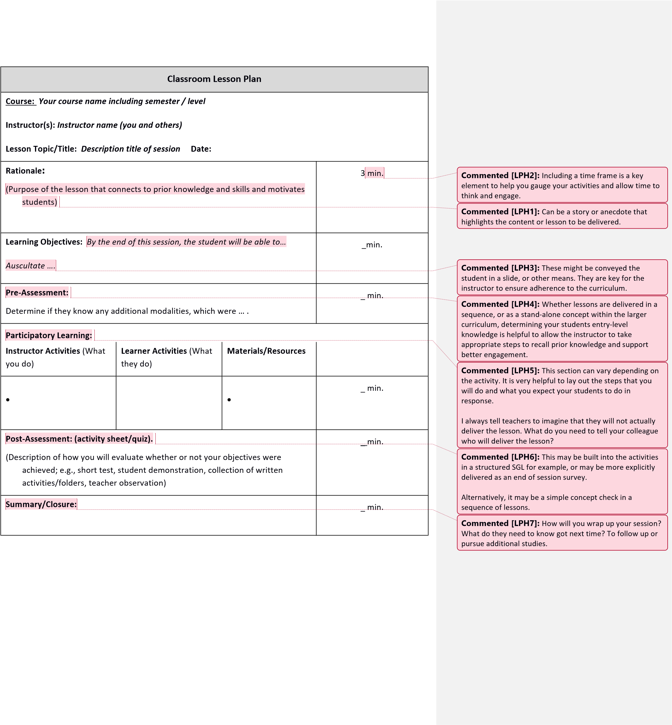

## Annotated Sample of Teaching Observation Document

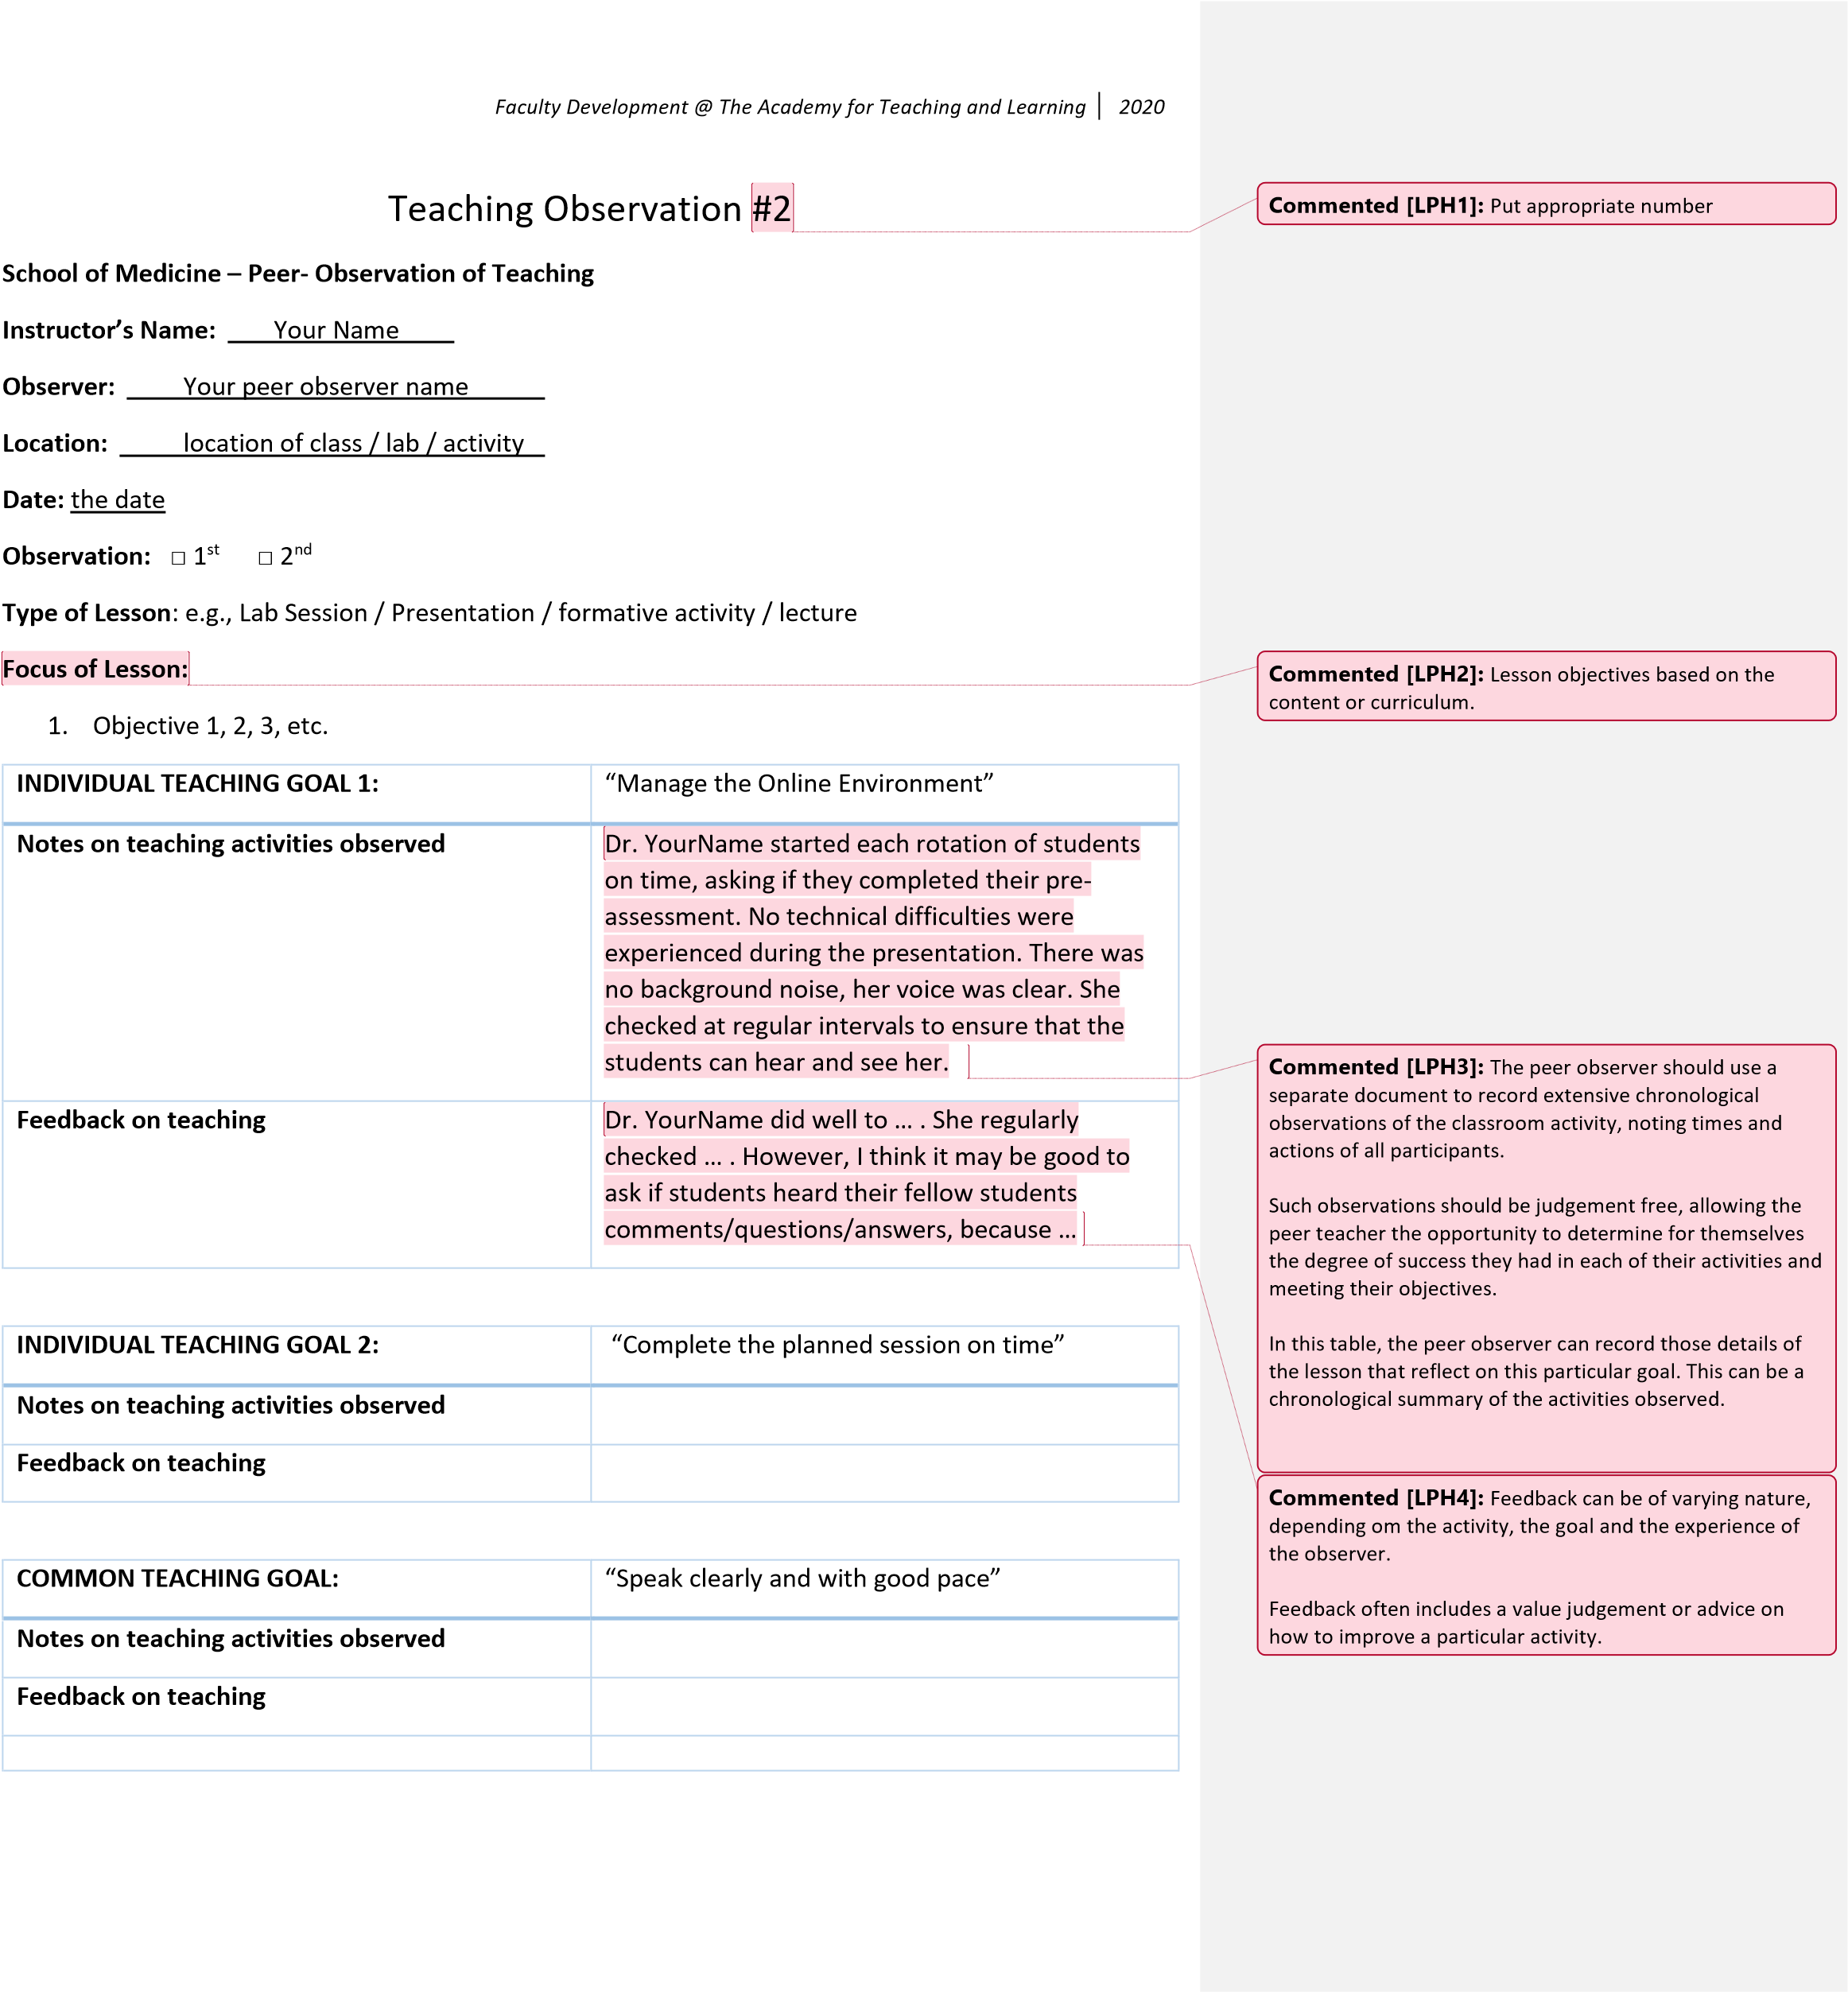

## Annotated Sample of Joint Statement Document

*Faculty Development @ The Academy for Teaching and Learning*

*2020*

Joint

Statement

–

Peer Observer and Peer Teacher

**Participants and Roles:**

•

Your Name

–

Peer

Teacher

•

Name of your

Peer Observer

:

**Activity Description:**

•

Name of activity

•

O

bservation date:

•

Joint Statement date:

**Feedback from Session**

Overall

,

__________

was highly effective at

achieving her teaching goals,

…. .

She

created a positive

e

nvi

ro

nment that was conducive

….. .

I think that

the observation activities have

hel

p

ed

her grow as a

teacher

…

.

She

ensured clea

r communication skills by

… .

**Advice and Joint Statement**

Dr.

__________

observed m

y classroom

for my second

observation

teaching

Semester 1 students

…

.

My peer observer

appreciated that I

incorporated her

feedback

into my teaching … .

I

gave

serious

thought to the comments and made every effort to develop in the areas indicated by my initial

feedback.

I also … .

I have

… . I

also improved on my time management by

… .

I hope that I can continue to … .

**Sig**

**ned**

I have read this and discussed the contents.

Peer Observer

Peer Teacher

***Your observer name***

***Your name***

**Commented [LPH1]:**

Should reference the

teaching

observation activities and

feedback and be written by the

peer observer, or in the peer observer’s voice.

**Commented [LPH2]:**

It is useful to state the setting for

the observation

**Commented [LPH3]:**

Comments on the nature of the

feedback and actions taken by the peer teacher to

incorporate feedback from initial

session or other sources.

**Commented [LPH4]:**

Comments on specific

goals.

**Commented [LPH5]:**

Plans for future practice as a result

of the observations.