Contents
Using Text Entry to Submit Multiple Items for an Assignment 2
Add a Kaltura Video 3
Add an Image 5
Add a Webpage Link 9
Add a File 11

Using Text Entry to Submit Multiple Items for an Assignment
You may be asked to submit multiple items for an assignment. If those items include one or more of the following, you will use the Canvas text entry box for submission.
- an image file
- a video
- a weblink
- and/or a comment
Here is a sample assignment we will walk through. Please create an infographic and record a video explaining the infographic. Submit both the original infographic and your video.
Click the Submit Assignment button on your assignment page to get started:
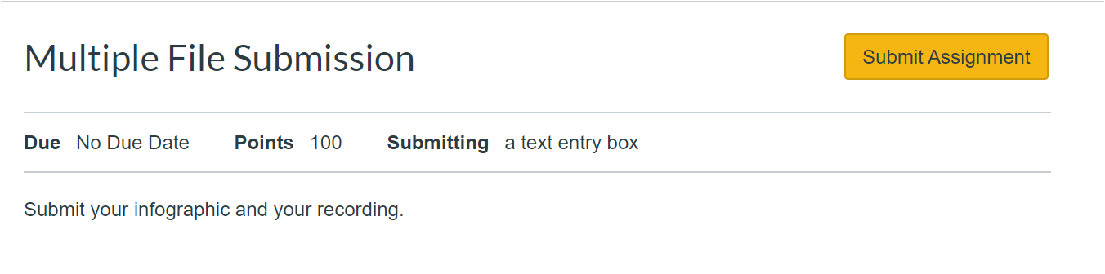
This will open a Text Entry box for you to use for submission.
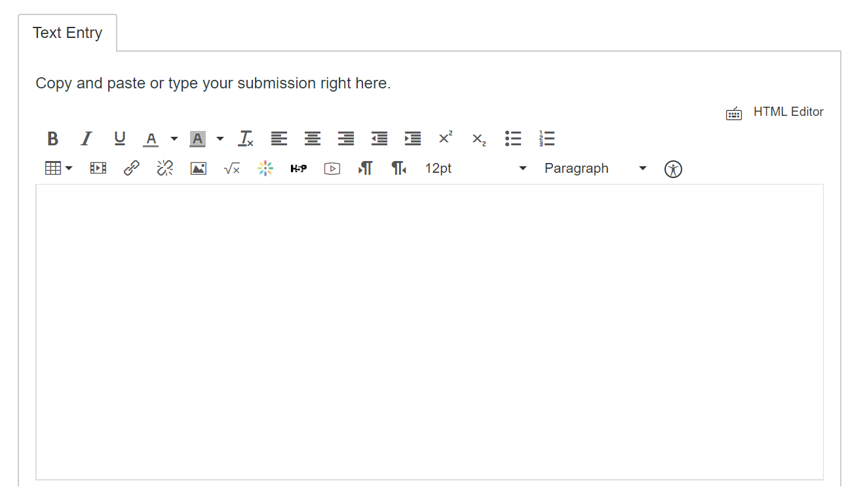

Add a Kaltura Video
Position your cursor inside the text Entry box and select the Kaltura video tool from the toolbar:
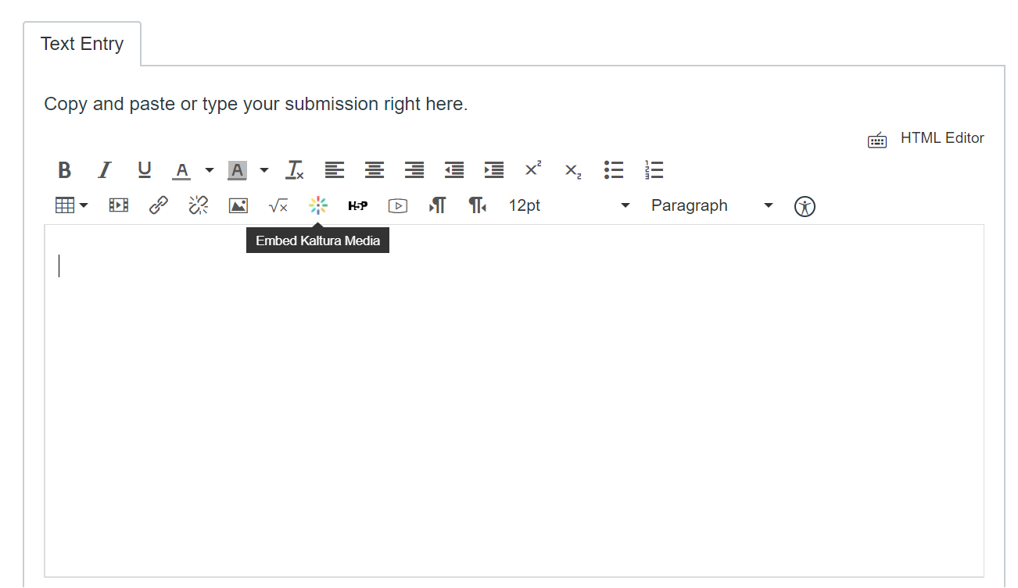
This will open your “My Media” folder. Locate your video recording. Click on the Select button to embed the correct video:
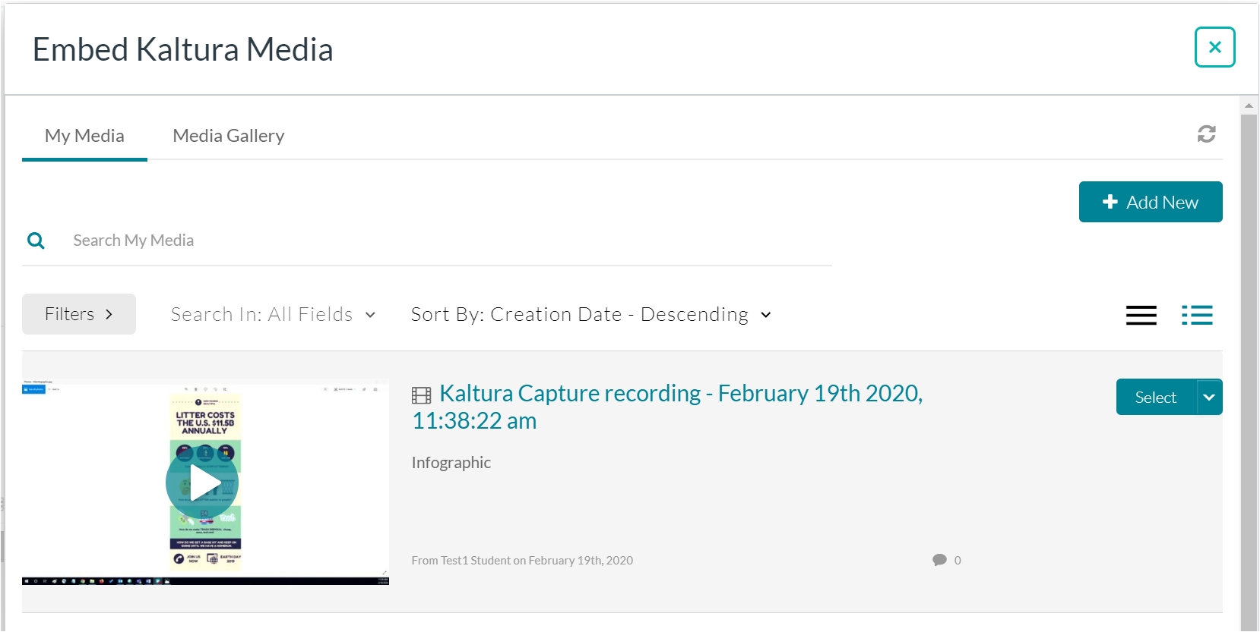
You will be returned to the Text Entry area and your video will be displayed.
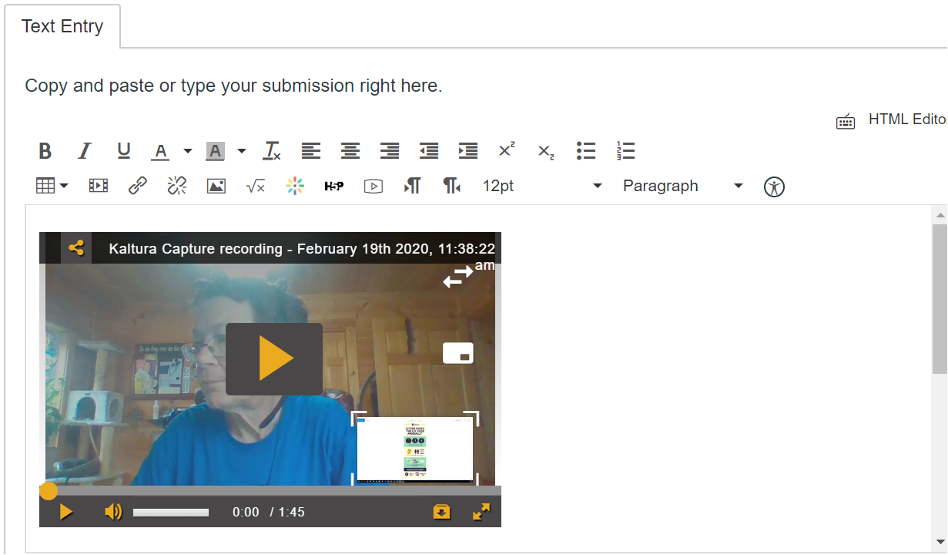

This space intentionally left blank.

Add an Image
Add your Infographic. If you have downloaded your infographic as an image (jpg or png file), you may add it to the Text Entry screen.
Click below your video and select the Embed Image icon.
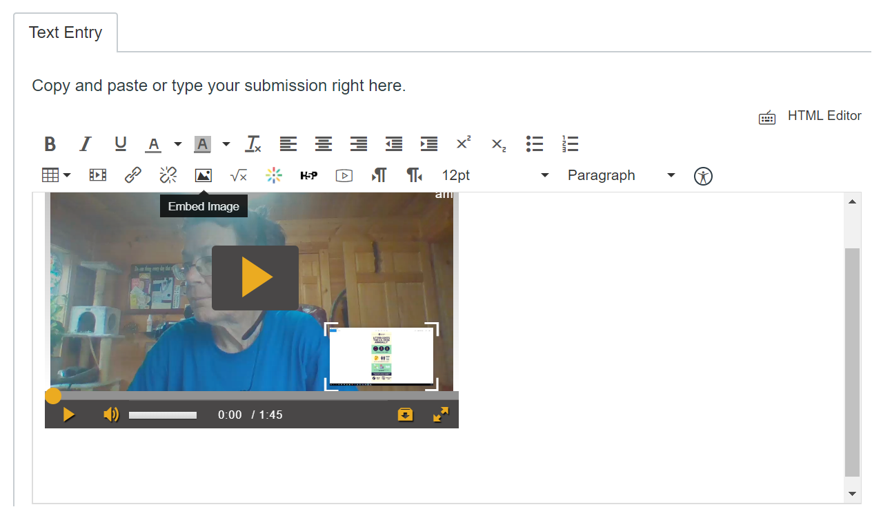

This space intentionally left blank.

This will open the Insert/Edit Image option. Click on My files and then Upload File to embed your image file:
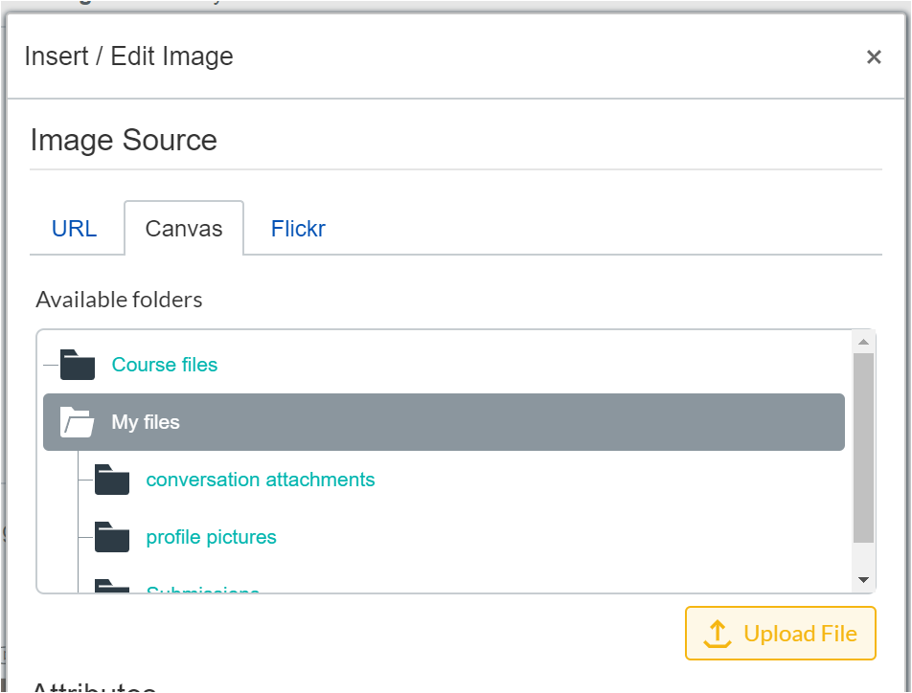

This space intentionally left blank.

This will open the file directory on your computer so that you may locate the file and upload it.
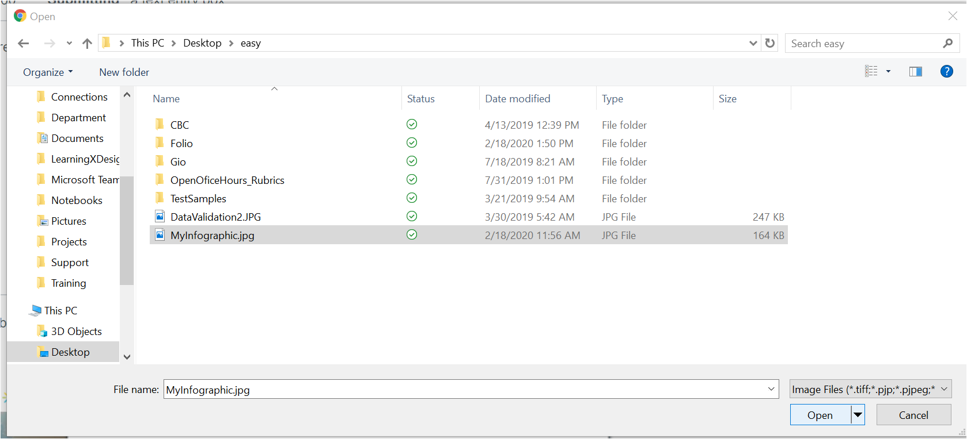
This will return you to the Insert/Edit Image area. Click Update to add the image to the Text Entry area:
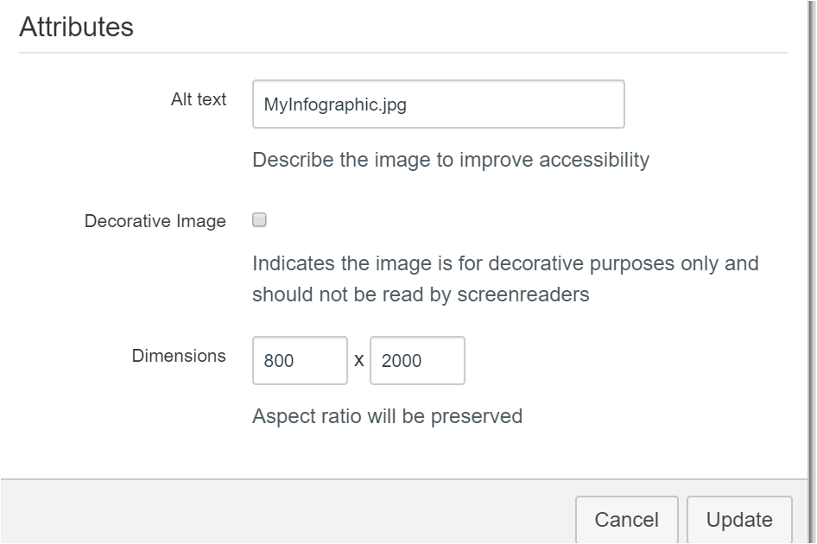

Both the video and the Infographic image will display:
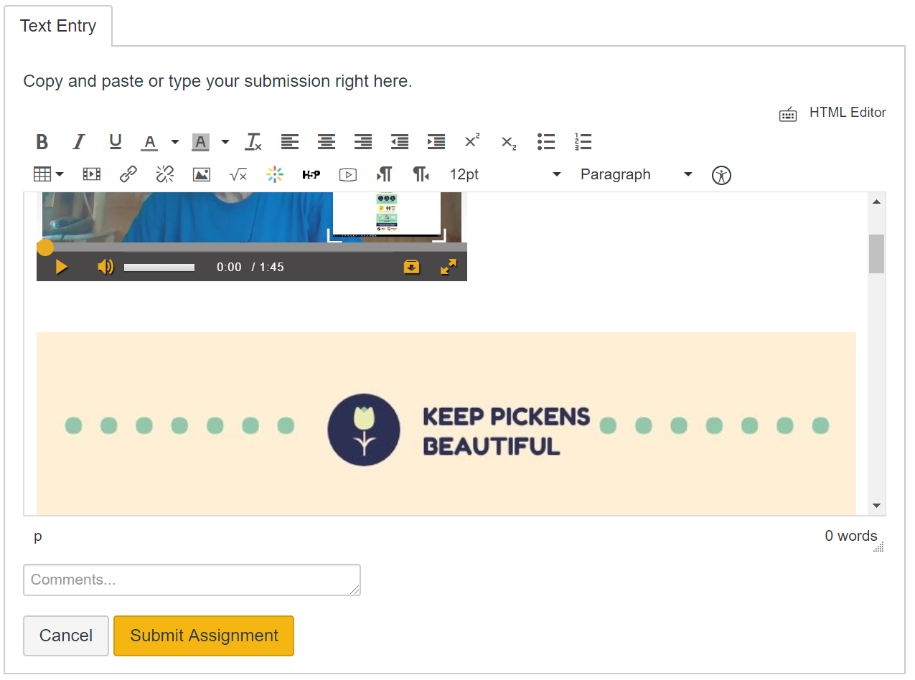

This space intentionally left blank.

Add a Webpage Link
If your Infographic is on a webpage, you may decide to link to it rather than saving the image file. In this case, you can add a line in the Text Entry box and type the link text you wish to use. In this example, I have typed My Infographic on the Web. Highlight the words and click the link tool:
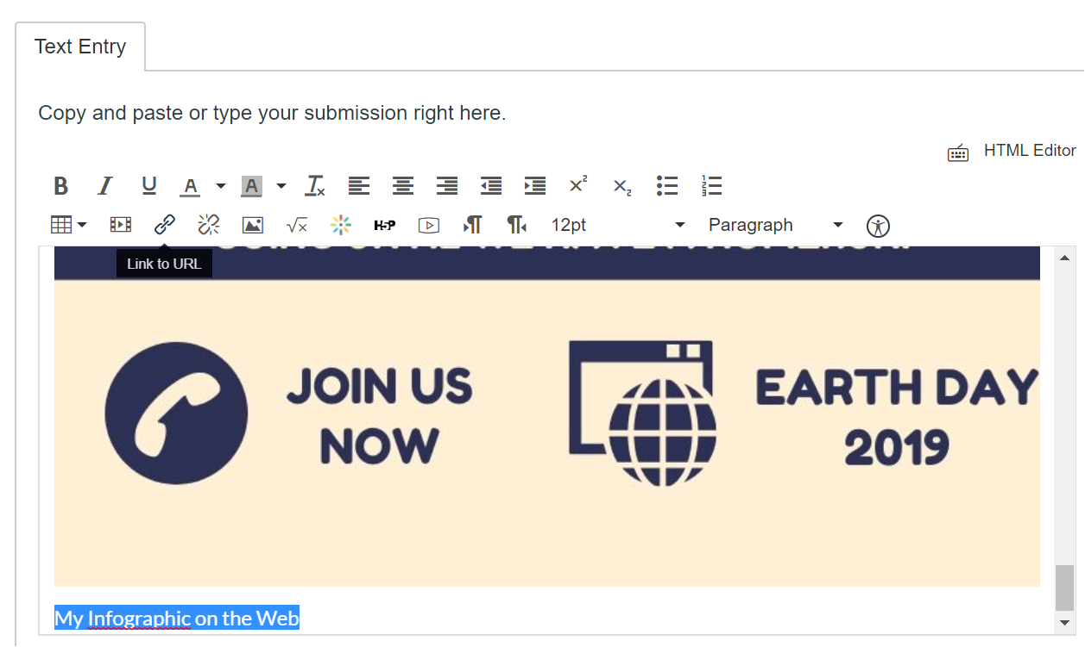

This space intentionally left blank.

This will open the Link to Website box. You will want to get the webpage address for your item and link it here. (In this example, I have gotten a link from a Canva Infographic:
Now I will paste it in the Link area and click Insert Link.
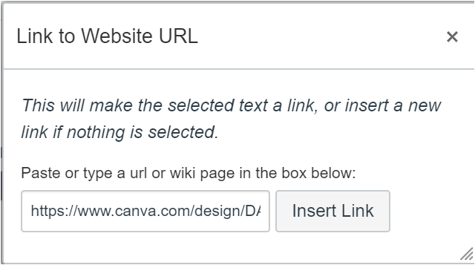
Click Submit Assignment to submit all of the work you have completed.

Add a File
If you have a file you need to attach to the assignment, you may add it as an attachment to the Comments box. On the Assignment page, click on Submission Details.
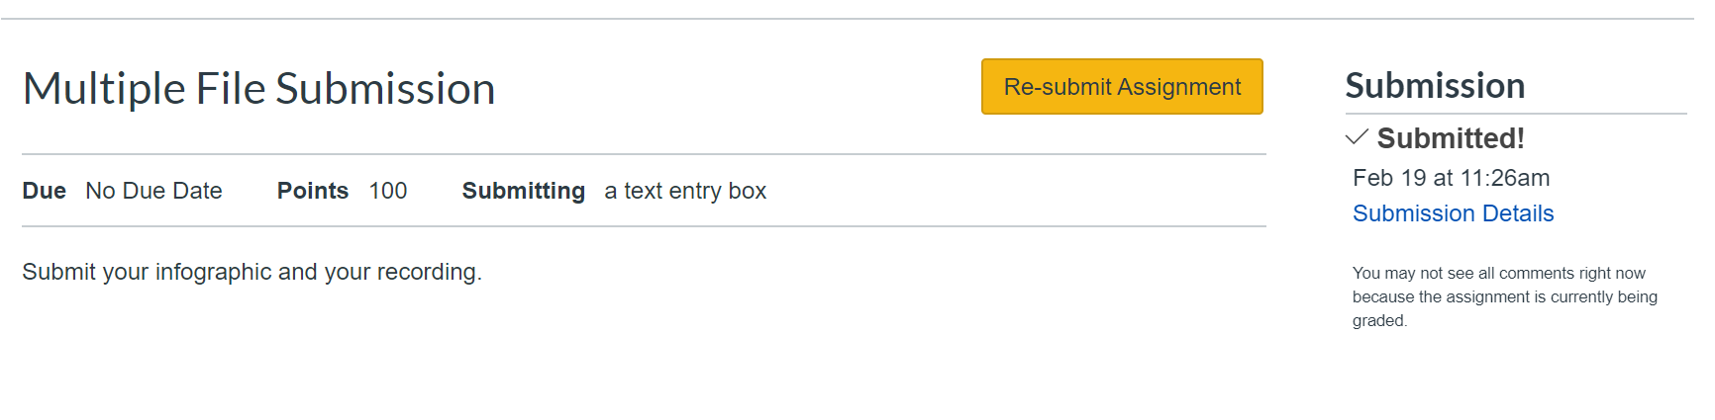
In the Add a Comment box, you may add your comment and use the Attach File option to attach a file. Use this if you have a file (pdf, Word document, presentation, etc.). Make sure to click Save when you have typed your comment and added your file.
